contorted and eventually can bulge or kink in such a way that a pocket, a diverticulum, is cut off from the proper flow through the intestines. When the diverticulum becomes infected and inflamed, the situation is called diverticulitis, and it is very painful. In the case of appendicitis the diverticulum occurs in the appendix. Surgery may be needed to correct this. Changing to a high fiber diet may help, provided fruit with small seeds are avoided. However, this painful condition can generally be prevented and sometimes reversed, by making it a habit to eat grains in the whole grain form, adding high fiber legumes to the diet and avoiding all refined grains and refined sugars.

Irritable Bowel Syndrome
IBS is manifested by bouts of constipation, diarrhea, gas and intestinal upset. In general there is no underlying disease, and it can be controlled very well with careful attention to the diet. In particular it is best to replace all refined grains with whole grains and to avoid refined sugar and other refined carbohydrates. It is very important to understand that the favorable microorganisms in the intestines are in need of a constant supply of soluble fiber, preferably from grains and legumes. If the diet swings back to refined carbohydrates, or anti-biotics are taken, these favorable microorganisms are easily replaced by others that promote intestinal upset. It takes up to two weeks of a whole grain based diet, with plenty of greens, legumes, vegetables and fruit, to re-establish a good microbiome. At the beginning it may appear that the whole grains and high fiber are not improving the situation, but perseverance is necessary and the result will be a much more stable digestive system. Help with re-establishing a healthy microbiome is available in the form of mixed bacteria probiotics.

Peptic Ulcer
Peptic ulcers can be caused by habitually taking aspirin and other potential stomach irritants. However they are less prevalent among people who take care to avoid refined grain foods, and instead eat whole grain foods and plenty of vegetables and fruits. Whole wheat supplies alkyl resorcinols that could help prevent infections in the stomach and intestines.

Cancer Prevention
A high fiber diet including whole grains, and excluding refined grains and refined sugars, makes it much less likely that cancers of the digestive tract will occur. Colon cancer is much more likely to occur when the diet is predominantly meat and refined flour based. Breast and prostate cancers are much less likely to occur when the diet has been high in fiber from whole grains, legumes, vegetables and fruits. Whole wheat supplies several compounds that are anti-cancer: tocols, alkyl resorcinols, lignans, and antioxidant phenolic compounds.

© Monica Spiller January 2017

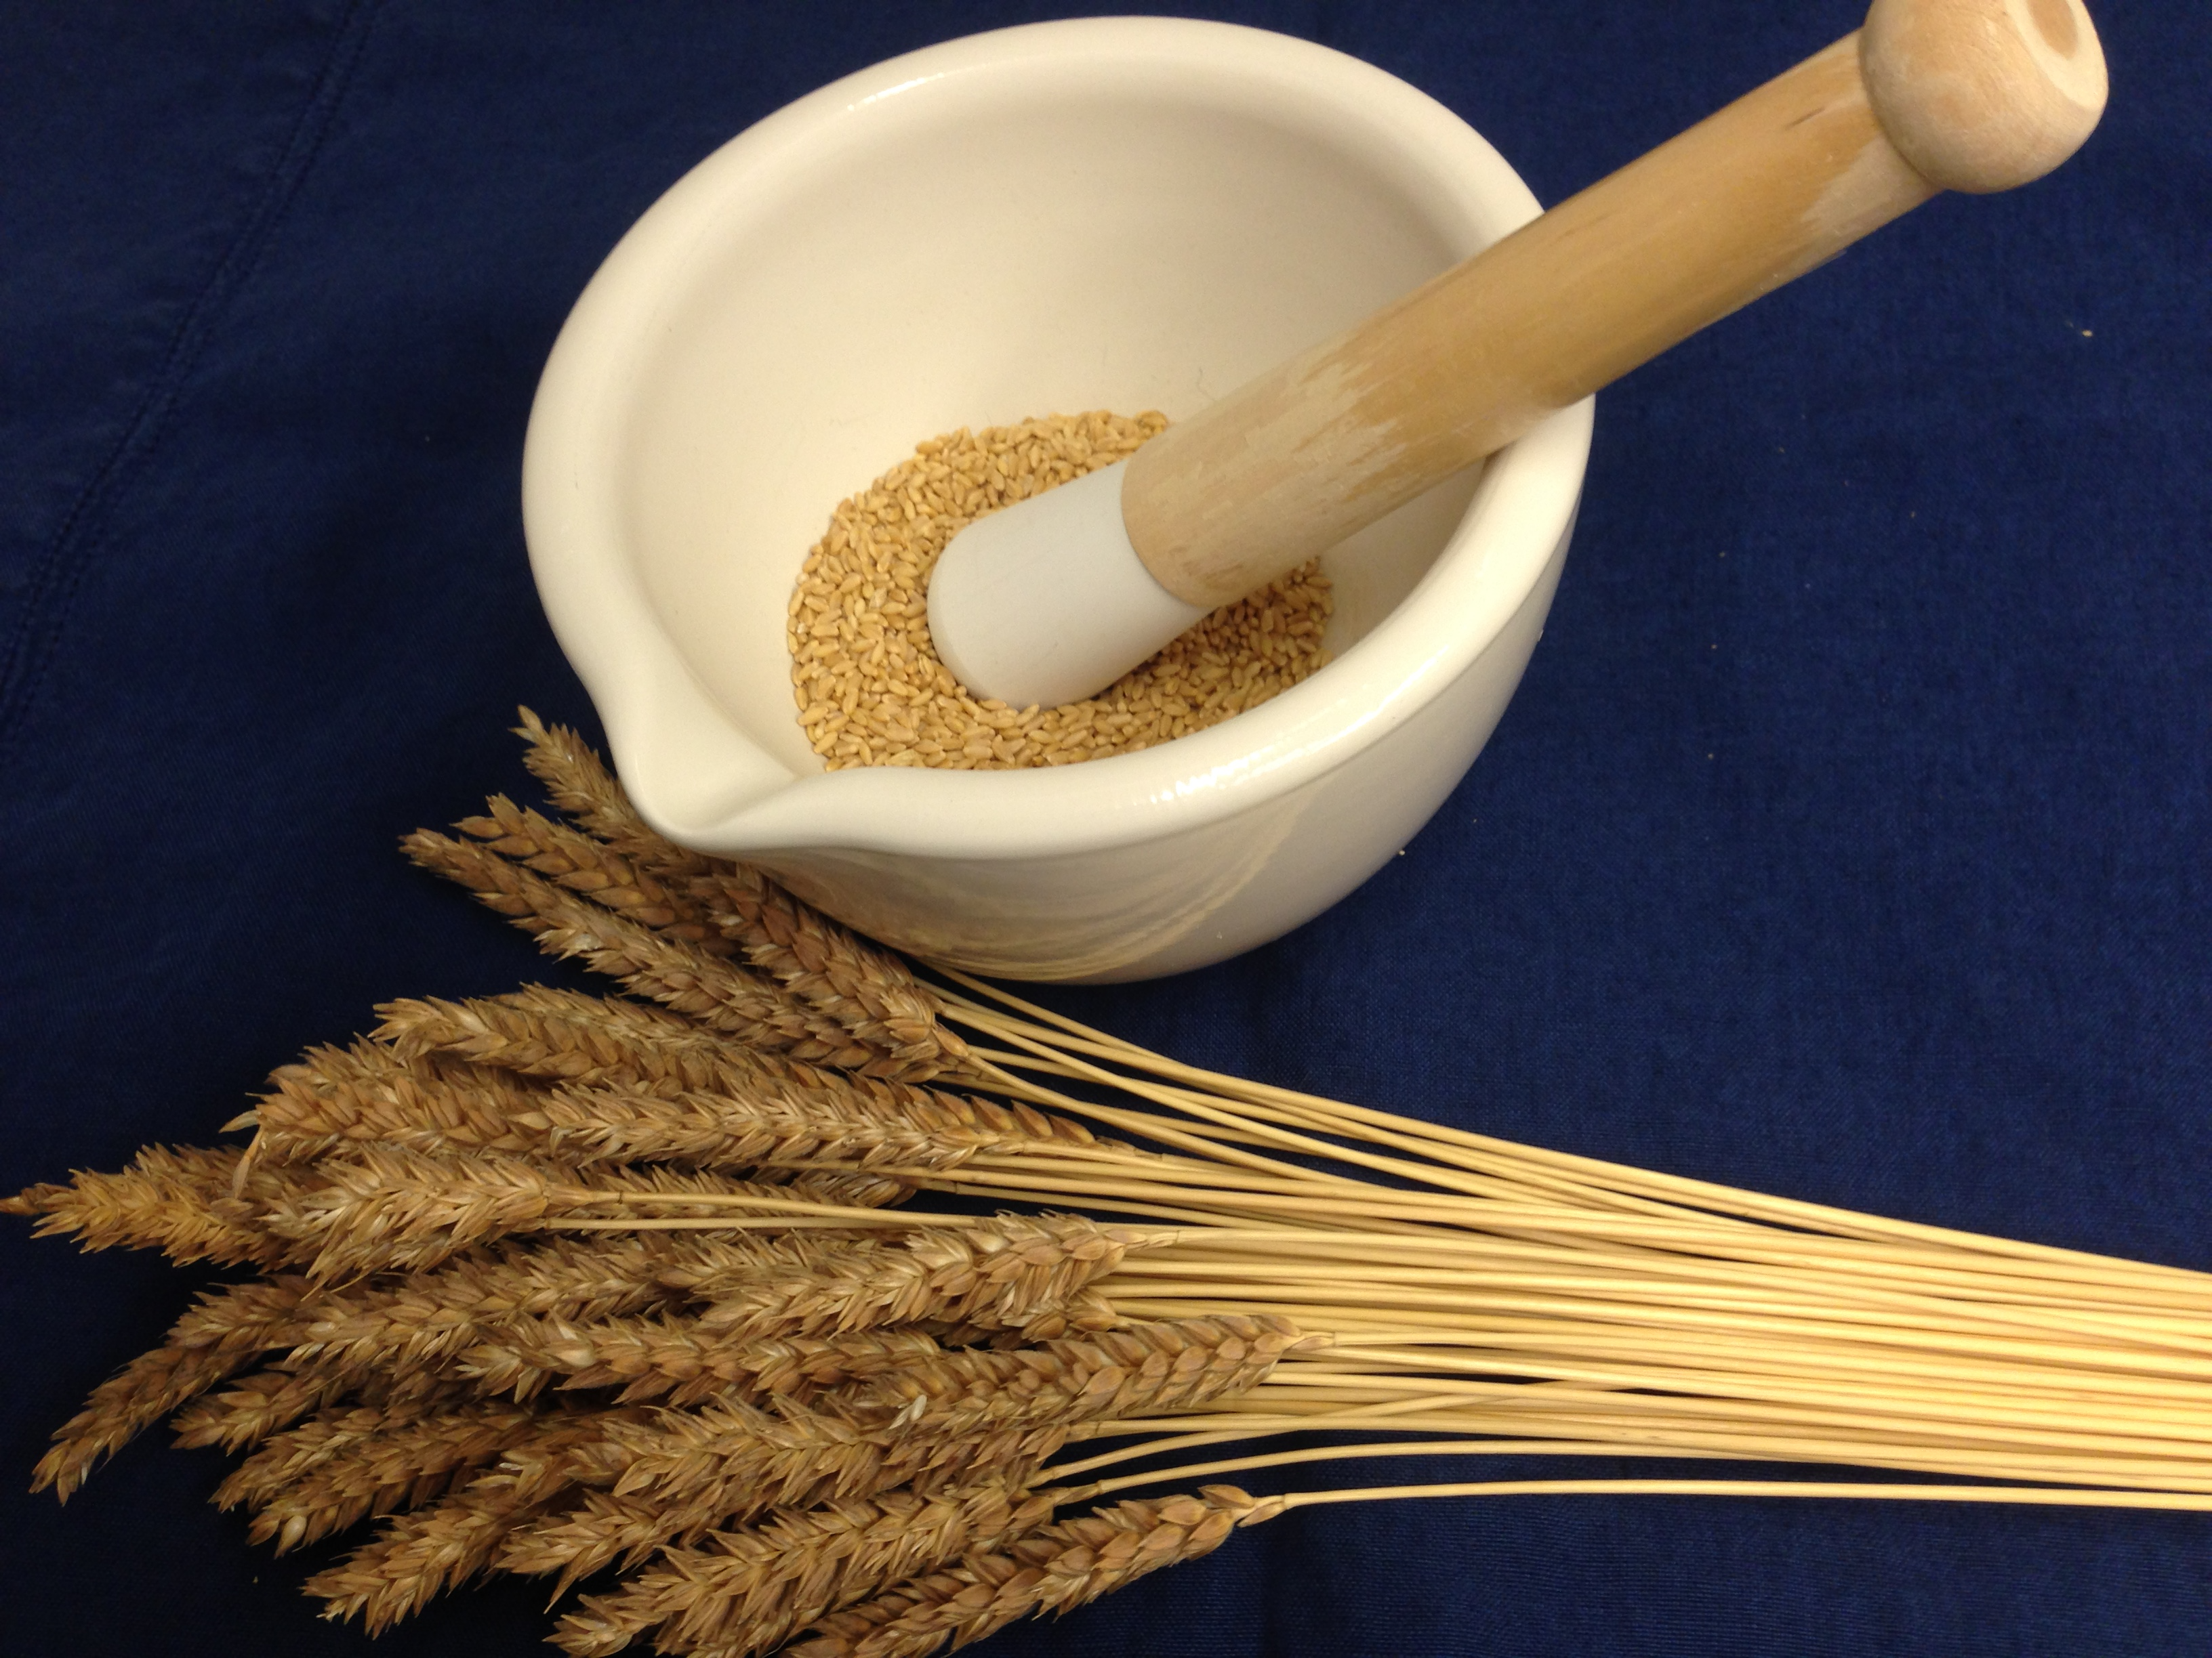

R_{x} Whole Wheat

High Blood Pressure
It comes as a surprise that whole wheat can help prevent high blood pressure. The secret is that there is a significant amount of potassium in whole wheat; enough in a whole-wheat based diet to help keep the balance with sodium in check. The potassium is located mostly in wheat bran.

High Blood Cholesterol & Triglycerides
A whole-wheat based diet reduces total cholesterol and favors high-density lipoproteins (HDL) in the blood, a reduced amount of low-density lipoproteins (LDL), and reduced triglycerides. Most of the credit for this is given to the dietary fiber from wheat bran and aleurone and the associated antioxidant phenolic compounds.

High Homocysteine
A high level of homocysteine in the blood is an indicator of risk for coronary heart disease and Alzheimer’s disease. Whole grains instead of refined flour and refined sugar products can reduce homocysteine levels. Whole wheat, supplies significant amounts of folate, choline and betaine from the germ and bran of the whole wheat grain. Each of these compounds will help reduce homocysteine levels in the blood, and they seem to work in concert with the B-vitamins and zinc, which are also present in the bran and germ, but practically absent from the endosperm.

Overweight & Obesity
When 100% whole wheat bread is substituted for the same weight of refined flour bread in the diet, the number of effective calories eaten is reduced by 10%. The effect is partly due to the fiber, which is not digestible. Over half a lifetime, this can account for middle age spread. Sufficient B-vitamins in the germ and bran of whole grains promote the full use of grain starches for energy, with less being converted to fat. The insoluble fiber in the bran encourages efficient elimination, and the soluble fiber helps maintain a healthy gut microbiome, which in turn favors healthy rather than unhealthy fat deposits. The antioxidant phenolic compounds in bran have a long held reputation as being capable of preventing excessive weight gain.

Hyperglycemia-High Blood sugar
Starch from refined flour, and sucrose from refined sugar, are both rapidly converted to glucose and appear in the blood very soon after a meal. However the starch from 100% whole grain bread only slowly appears in the blood as free glucose. One explanation could be that phenolic compounds in the blood bind with glucose, leaving less free glucose in the blood. A lower presence of free glucose in the blood is accompanied by a lower insulin response. This lower insulin response also means less of the glucose will be converted to a fat deposit.
The lactic bacteria in sourdough leavened 100% whole grain bread are capable of releasing considerable amounts of phenolic compounds from the whole grain into the bread. These phenolic compounds enter the bloodstream at the same time as the glucose, combine with the glucose and leave less free glucose in the blood to stimulate insulin secretion. For this reason sourdough leavened 100% whole grain breads rather than yeast raised refined flour breads, are important as the base of the diet intended to moderate the appearance of high levels of glucose in the blood, following meals.
Whole grain pasta and cereals undergo fermentation in the intestines with the release of phenolic compounds that enter the bloodstream. Thus the combined effects of previously eaten whole grain foods and immediately eaten sourdough whole grain breads, is to maintain a fairly steady concentration of phenolic compounds in the blood, which are available to bind with excess glucose as it enters the blood following each meal.

Pre-Diabetes, Diabetes & Coronary Heart Disease
Diabetes is a major risk factor for CHD.
The risk factors for diabetes and therefore also for CHD include obesity, high blood pressure, increased LDL in the blood, high homocysteine concentrations in the blood, and high values for fasting blood glucose. Eating 100% whole grain versions of sourdough bread, pasta and cereals, cutting out all refined flour products, and replacing refined sugar with whole (fresh or dried) fruit will help prevent diabetes and CHD and can aid in significantly reversing the risk. Whole wheat supplies several protective compounds, magnesium, tocols, alkyl resorcinols and lignans.

Constipation
Whole grains, especially wheat and rye supply bran, which is almost completely undigested by the enzymes in our system. Bran supplies insoluble fiber to carry food all the way through our system, and also some soluble fiber. The soluble fiber feeds the microorganisms in the intestines and these bacteria add to the bulk already produced by the wet bran. We have no other source in the diet for such bulking agents. Fruits and vegetables supply fiber and are also necessary as a source of fiber, but it is very much less and of a different type than whole grains. Legumes are rich in dietary fiber and best also added to the diet to help prevent constipation. Bran from whole grains is a major help in preventing constipation.

Diverticular Disease & Appendicitis
People who have for a lifetime based their diet on refined flour and refined sugar, and perhaps also too few fruits and vegetables, are usually chronically constipated and the intestines become

