The Whole Grain Connection Newsletter #26
February / March 2019

Changing times! A call for action!
When the internet-connected telephone, the iPhone, was introduced by Steve Jobs as something much more useful even than the cell phone; were we still sold cell phones because that is “what we were used to” and had already been buying? Did the producers just go on making cell phones and push them hard with tantalizing slogans like “artisan” and “organic”? Everyone knows the answer is that the cellphone with the added internet connection, the iPhone, was a far more useful package, and so did the producers. Look what happened to the fortunes of those who followed through with this, and produced the more useful package, the iPhone; they are among the wealthiest of all.
Why then do the producers of flour lacking the bran and germ, that could make the package for baking complete and so very much more beneficial to our health, continue to make and push refined and sifted flours? The market is flooded with a supply of these now completely outdated, refined, sifted, de-germed and polished grain foods and foods with added refined sugar. The suppliers know that we must eat, and they are still callously forcing the supply. This is definitely not the demand.
The demand is for foods that will keep our weight steady, and our bodies and mind healthy. We want to be kept free from the chronic diseases that now plague the Western World, and which were almost completely absent before the introduction of these refined grains and refined sugar in glut quantities for the masses in the Western World.
So be warned, if you are still a producer or pusher of refined grains and refined sugar. The evidence is written in the reports of myriad conscientious scientists who have worked diligently since the beginning of grain refinement to figure out just what is going on with our health when we omit grain bran and germ. Most of that research has been in Universities and Clinics with our tax dollars! They’ve learned a great deal; enough to know that if we ate our grains whole and avoided refined sugar, we really would not need to support the healthcare for millions suffering from diabetes, cardiovascular disease in the young or colon cancer and much more. In California alone the health care costs each year just for these three diseases is $50 billion. Public policy is bound to change in the face of these astronomical healthcare costs.
For those looking to mill and bake from this day forwards, there is every reason to invest in the infrastructure needed for whole grain foods. Where is the government help, of the kind injected into the car industry, to provide monetary incentive for the retrofitting of the milling and baking industries? Is car production and associated jobs more important than healthy food production and those associated jobs?
There is no need to fear that whole grain products will not be acceptable. Those of us who have heard this call to action have been acting, even in the absence of help. We make delicious and desirable 100% whole grain products without added sugar. For a start we do not rely on only one main type of grain, we’ve diversified the possibilities. We use sourdough leavening that does not require added sugar and can produce a mild, or intense flavor according to taste. We have realized that whole grain flour is at its best when freshly milled. This means that the new infrastructure consists of locally stored clean grains distributed locally to simple stone mills in the hands of local millers, miller-bakers, miller-chefs and home miller-bakers. This infrastructure allows for locally grown grains to be used and appreciated locally as they were before we had this centralized conventional commodity system. And the agricultural system we have been using to produce these grains locally is organic and aims to be regenerative and climate change mitigating. There is no place for herbicide or pesticide use since the bran and germ would receive them on the exterior of the grain.
Let’s ask for government help at the local, state and federal level, to retrofit milling and baking for whole grain end products. The change will be costly to achieve, but the status quo is untenable!

Prescription for food: Mediterranean Diet with grain food whole
At the same time as we attempt to obtain government help in making whole grain food available for everyone, we can canvas our local hospitals and clinics to tell their patients where there are local bakers producing thrilling 100% whole grain breads without added sugar.

Stone Miller Connections - Sharing Stone Mill maintenance skills
For five decades Roger Jansen has shared the mill wright skills he originally learned on the job at Meadows Mills. Roger has honed those skills over the years and builds his own design of Jansen Grist Mills now, as well as continuing to teach others how to dress granite stones and generally maintain stone mills. Where would we be without such teaching all this time. Fortunately, besides the Jansen family, a representative of a younger generation has realized the need and the challenge of producing truly modern stone mills: Andrew Heyn has studied the art and science of the mill wright and has embarked on his own stone mill building enterprise: New American Stone Mills.
Even so we have realized that, we the students of Roger Jansen and Andrew Heyn need to share that knowledge. One way is to encourage professional stone mill owners to contact each other, and visit each other, when they would like to have advice, regarding their mill maintenance. Hence the creation of a list of professional stone mill owners. This could be especially useful for new owners, when the stones need re-dressing, or the stones need to be re-balanced, or even replaced. There are also other tasks that new stone mill owners will want to experience hands-on initially.
The skill of dressing granite millstones has been modernized and once learned is no more difficult than some other maintenance tasks needed on a piece of machinery.
Some modern stone mills are now made with composite millstones intended for long time use without dressing, but the whole mill still needs to be cared for properly if these stones are to perform well for a long time.
In some cases, help with maintenance is available by directly contacting the makers of stone mills. In fact, the availability of such help should be part of determining which brand of stone mill to choose when initially purchasing.
If you are a professional stone mill owner producing flour for sale or use in a bakery selling the bread, and would like to be on this list, please contact Monica Spiller via e-mail: barmbaker@aol.com

Test loaf: 100% whole wheat sourdough leavened
The choice of wheat varieties to bake with, beyond the hard-red wheat that we have been accustomed to for so long, can be overwhelming. Stone milling and baking on a small scale, saves time and ingredients. To this end, there is a recipe and method in the recipe section of the website for testing wheat for its baking characteristics as a 100% whole grain sourdough leavened loaf. The test needs just 125 grams of grain. (A full-size loaf can be regarded as one made with 500 grams of grain.)
This test loaf can be made up with new grain, and again when the same grain is several months old, to notice any change in hydration needs. Also, the loaf can be made with varying amounts of water to discover which hydration you would like to use in your own formulation. Many variations are possible for comparison, one variation at a time, and always keeping both the flour amount and the starter constant.
This is actually my basic bread recipe, most often made up with Sonora or Durum Iraq. It seems that my starter is more potent as a leavening agent after repeatedly replenishing it at 86 ºF and also making the bread at that same temperature. Perhaps with these conditions I am favoring a highly acid tolerant yeast that’s giving the improved loft?

Whole grain defectors and returners
In the 1970s and 1980s whole grain baking was synonymous with owning a stone mill, producing whole grain flour, making bread with this flour using various sourdough starter systems, and finally baking the bread in a woodfired brick oven. All this was known as “artisan” baking. Dave Miller at his Miller’s Bakehouse near Chico, California, is one of few who have continued baking bread this way ever since that time, and who continue to teach their whole grain methods.
However, you’ll notice that “artisan” these days, indeed since the early 1990s, has been attached instead to sourdough leavened breads made with organic refined unbleached and unenriched flour, with artisan shaping and perhaps baked in a woodfired oven. Steve Sullivan of Acme Bread fame is one of the most famous in this group, as is Craig Ponsford originally in his Artisan Bakery. Keith Giusto even broke away from his family's business, which was providing stone milled whole grain flour and delicious 100% whole grain breads, in order to produce organic refined flour for the new style artisan baker. Defectors from whole grain baking to this white flour artisan system included many other famous bakers: Chad Robertson, Alan Scott, Thom Leonard, Peter Reinhart, and the list goes on. Most have partly returned by baking breads with some freshly ground whole grain flour added to their organic unbleached and unenriched refined flour. Some even produce a few 100% whole grain breads. Most seem to have lost their way back to appreciating that the grain needs to be whole, and that anything less robs us of essential nutrients.
Other defectors are even more surprising: PhD Agricultural Scientist Bob Quinn was the original producer of the interesting ancient Kamut wheat. Kamut is his trademark name for khorasan wheat. At first it was presented in the whole grain form. Nobody thought to eat it any other way, since the flavor is wonderful and people eating it felt healthier. Even so the scale of usage was small compared with the possibilities in the larger commodity system. Bob Quinn is a master marketer and he expanded his horizons beyond the small scale stone millers and sought out the large millers, who are actually limited by their roller milling systems to producing refined flours. They refined the Kamut to semolina flour for pasta! And the next thing we knew was that Kamut pasta on grocery store shelves was transformed into refined semolina products without the nutrients (in the bran and germ) that had given it such a healthy and tasteful reputation. Spelt introduced and popularized around the same time as the Kamut has suffered the same fate, but does not have such a brilliant marketer as Bob Quinn. "Grain by Grain" the new book by Bob Quinn and Liz Carlisle, documents the Kamut story.
The excuse for all this was that whole grain breads had a reputation for poor taste and texture. By now we have had plenty of time to understand how to make 100% whole grain breads using varieties of wheat beyond the modern hard red, and others introduced by breeders since 1900. Varieties that predated the late 1800s introduction of roller milling were practically absent before 2000, except for the khorasan and spelt. Besides this, there are some new and efficient motorized stone mills that enable everyone, from the home baker to the commercial baker, the chef and the commercial miller to produce fine fresh 100% whole wheat flour "at the ready" for baking into superb 100% whole grain products.
Perhaps the stumbling block was the attempt to equate loaf volume from equal weights of refined flour and whole grain flour. Really the whole grain flour contains only about 75% of the gluten structure-forming protein than would be found in refined flour! Knowing this, it doesn’t make sense to add more water to whole grain flour than you would to a refined flour dough; less water is needed or about the same. It’s a myth that the bran needs lots of water; the bran actually needs only to be slightly moist to be flexible in the dough. Also, just a small amount of added oil or fat reduces the water holding capacity of the bran and makes it suspend better in the gluten, yet still allows it to remain flexible. Of course, the style of bread also determines the water to add, but the comparison stands whatever the style.
There are by now some open-minded younger bakers, with their own stone mills who are making 100% whole grain breads. What a relief to find them: Josey Baker at “The Mill” in San Francisco, Thomas “Mac” McConnell at “The Midwife and the Baker” also in the SF Bay area, Grayson Gill at “Bellegarde Bakery” in New Orleans, and others that you can find in the list of whole grain bakers on our website. However, you still need to make sure that you are asking for their 100% whole grain breads, because sadly the diluted kind is likely also still being made.

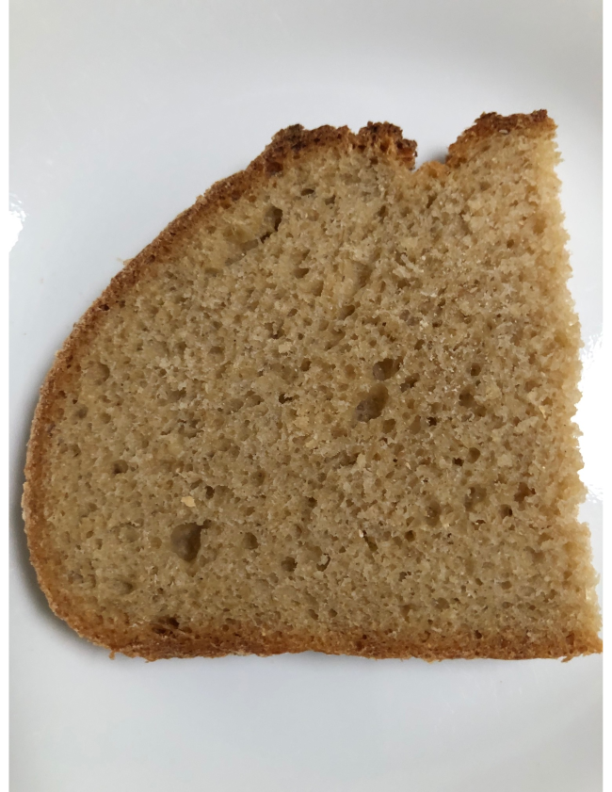 | Here's a slice of 100% whole Sonora wheat bread: 65% water, 4% extra virgin olive oil, 1% enzyme active barley malt with vitamin C, 1.5% salt, 10% fully mature starter. All % values are with respect to the flour. All fermentations were at 86ºF (30ºC).  Full sized basket raised loaf based on 500 grams flour, baked with humidity in the oven at 425ºF for 45 minutes.  Method as for test loaf above.  The texture is light and very absorbent, with creaminess of texture and flavor.  This is just a possibility, rather than an ultimate formulation.

