When summer herbs such as basil and spinach are plentiful then a raw Pesto Sauce can be prepared to flavor the cooked pasta ribbons. Fresh leaves are finely chopped in a food processor together with olive oil, a little garlic, nuts and Parmesan cheese, salt and pepper.

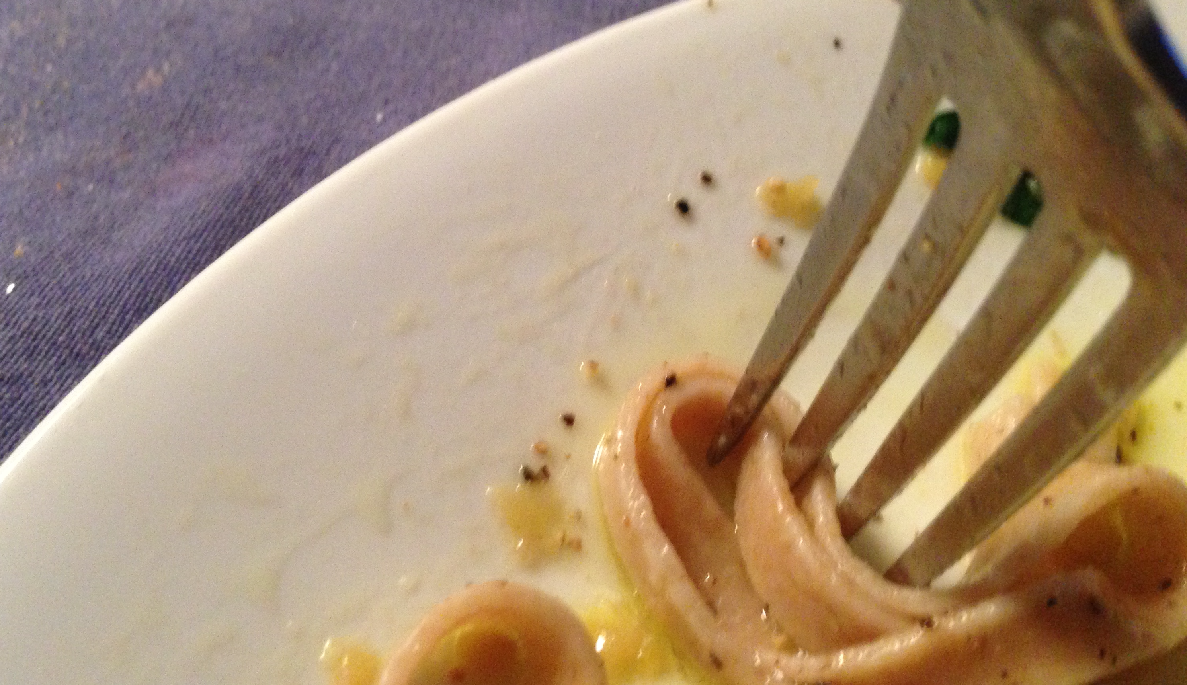

Indian Rotis from whole Durum-Iraq wheat flour
To make the dough for rotis, a small amount of ghee or olive oil is rubbed into the flour. Separately enough water is measured out to make stiff dough. This water is mixed with a little salt and sourdough starter, before mixing it into the flour to make the dough. The stiff dough is closely covered to prevent it from drying out, and is kept in a warm place until it swells to nearly twice its original size. Knead the dough briefly. To shape the rotis, break off and round egg-size pieces of dough and roll them out into a very thin disk. Allow the shaped rotis to rest, on and covered with a cloth, while heating the oven or griddle. Rotis can be oven-baked in one minute or less on a pizza stone in a very hot oven, or baked on a hot griddle. For detail go to: www.wholegrainconnection.org

Italian focaccia from whole Durum-Iraq wheat flour
To make focaccia dough, some olive oil is rubbed into the flour. Separately enough water is measured out to make medium soft dough. This water is mixed with a little salt and sourdough starter, before mixing it into the flour to make the dough. The dough is covered and is kept in a warm place until it swells to twice its original size. To shape the focaccia, the dough is flattened and kneaded briefly until smoother in texture, shaped into a ball and eventually into a disk approximately half an inch thick. Rest the dough-disk between cloths while heating the oven. Bake on a pizza stone
in a very hot oven or on a medium hot round griddle with a lid. For detail go to: www.wholegrainconnection.org

Whole Durum-Iraq wheat & your health
Breads and pasta can be made with organically grown, 100% whole Durum-Iraq wheat flour. All of the bran and germ are included so providing plenty of B-vitamins to aid in the efficient assimilation of the starch and gluten protein from the grain endosperm. The bran also provides a balance of insoluble dietary fiber and prebiotic soluble fiber. In addition the bread or pasta-making processes increase the amount of resistant starch, which acts like fiber in the digestive system. Whole Durum-Iraq wheat products are a useful addition to the diet, especially for people who are working to maintain normal blood sugar levels, by avoiding refined flour products and refined sugars.

© Monica Spiller. December 2016
Ancient Durum-Iraq wheat
Durum-Iraq wheat is a classical durum wheat that has been grown in Iraq for millennia. This is why Durum-Iraq can be called an ancient or landrace grain. Whole Durum-Iraq wheat flour makes exceptionally good Indian rotis and Italian focaccia as well as pasta, with a chewy texture that holds up very well during cooking; it has a mild nutty, buttery flavor.
Seed collected in Iraq in 1983 has been grown in California since 2000 and in Montana since 2014.
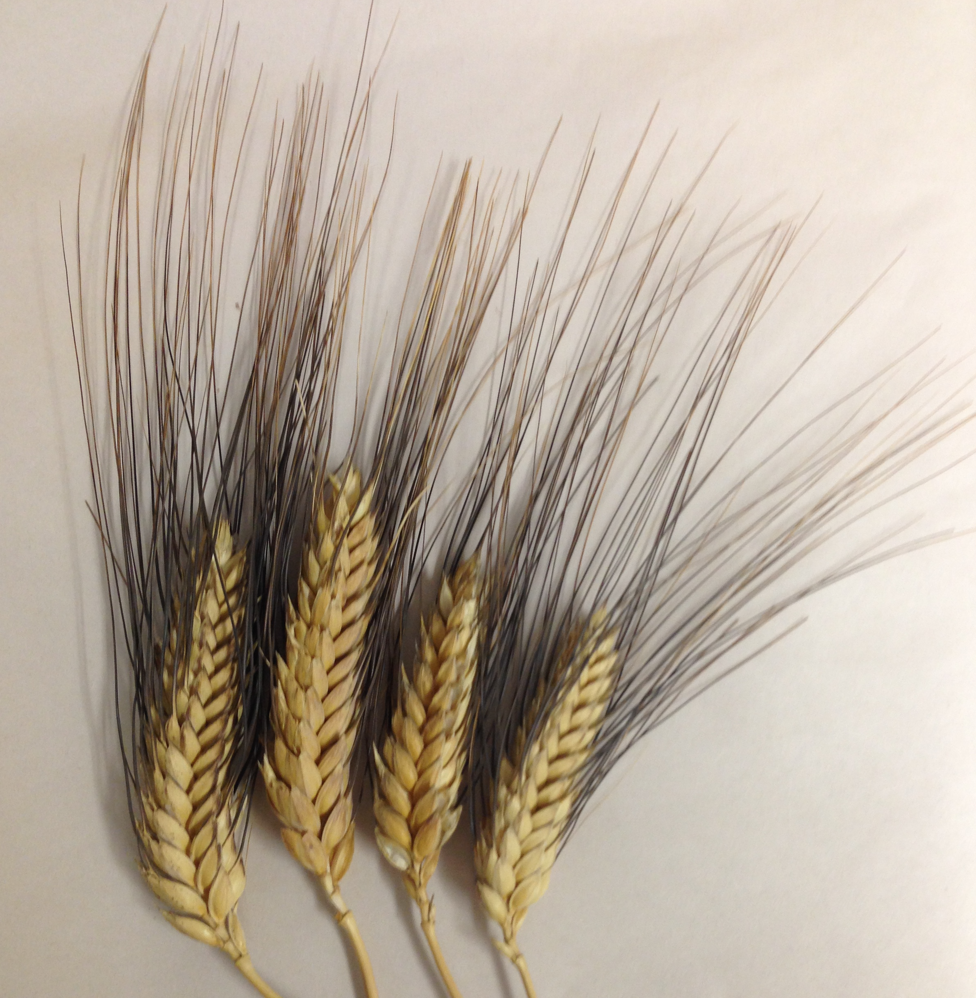

Fresh stone milling of Durum-Iraq
Durum-Iraq wheat is best if freshly stone milled to whole wheat flour before making products, so preserving the flavor and nutrients in the whole grain.

The ideal way to cook pasta and preserve the nutrients for the eater is to cook the pasta so that all the cooking water is absorbed, or to cook the pasta in a soup, stew or casserole so that all the nutrients are kept in the same dish.

Whole Wheat Durum-Iraq Vermicelli
Preparation as a side dish (1-2 servings)

Water | 1 cup
Salt (optional amount) | ¼ teaspoon
Durum-Iraq Vermicelli | 1 cup

[] In a saucepan with lid, bring water and salt to a rolling boil.
[] Add Durum-Iraq vermicelli to the boiling water and stir with a fork.
[] Allow the mixture to boil (without lid) until the vermicelli have expanded and almost all the water has either been absorbed or evaporated away, 3-5 minutes. Stir well with a fork especially towards the end as the water evaporates.
[] Remove from heat and place lid on saucepan. Set aside for a few minutes before serving

Traditional uses for Vermicelli
European and Asian soups are easily made hearty with the addition of vermicelli. At the end of cooking soup add ¼ - ½ cup vermicelli per cup of soup. Simmer for a further 4-5 minutes to allow the vermicelli to cook and expand. Stir and serve.

Indian Uppma is prepared as a one-pot meal for breakfast or lunch. A selection of flavors from mustard, cumin, fenugreek and sesame seeds, Chile peppers and ginger root are sautéed in ghee or oil in a heavy bottomed skillet or casserole, possibly followed by a small amount of chopped nuts or lentils, and vegetables in season. When the vegetables are almost cooked, water is added (½ - 1 cup per serving) followed by vermicelli (¼ - ½ cup per serving). Chopped herbs and greens can be added, the cooking is continued and the mixture stirred well until the water has been fully absorbed by the vermicelli. Serve with more chopped fresh herbs and lemon juice.

Indian Seviya Kheer milk pudding is generally made on top of the stove, and takes 20 minutes or more of constant stirring, but it can also be baked in a deep baking dish. Some of the milk, pitted dates, almonds, cashew nuts or pistachios can be ground up in a blender, and combined with ¼ cup of vermicelli per cup of milk. Bake at 300ºF. It helps to make the pudding creamier by stirring once or twice during the first hour of baking.

Whole wheat Durum-Iraq Ribbon pasta
Preparation as a side dish (2-4 servings)

Water | 1 quart
Salt (optional amount) | ½ teaspoon
Durum-Iraq Ribbons | ¼ pound

[] In a large saucepan, bring water to a rolling boil. Use enough water. Do not crowd pasta in the water.
[] Grasp a small handful of pasta ribbons and place one end of the pasta in the boiling water. As the pasta softens and collapses into the water, spiral the full length of the ribbons into the pan.
[] Cook the pasta at a full rolling boil. Stir gently with a fork to separate the pasta
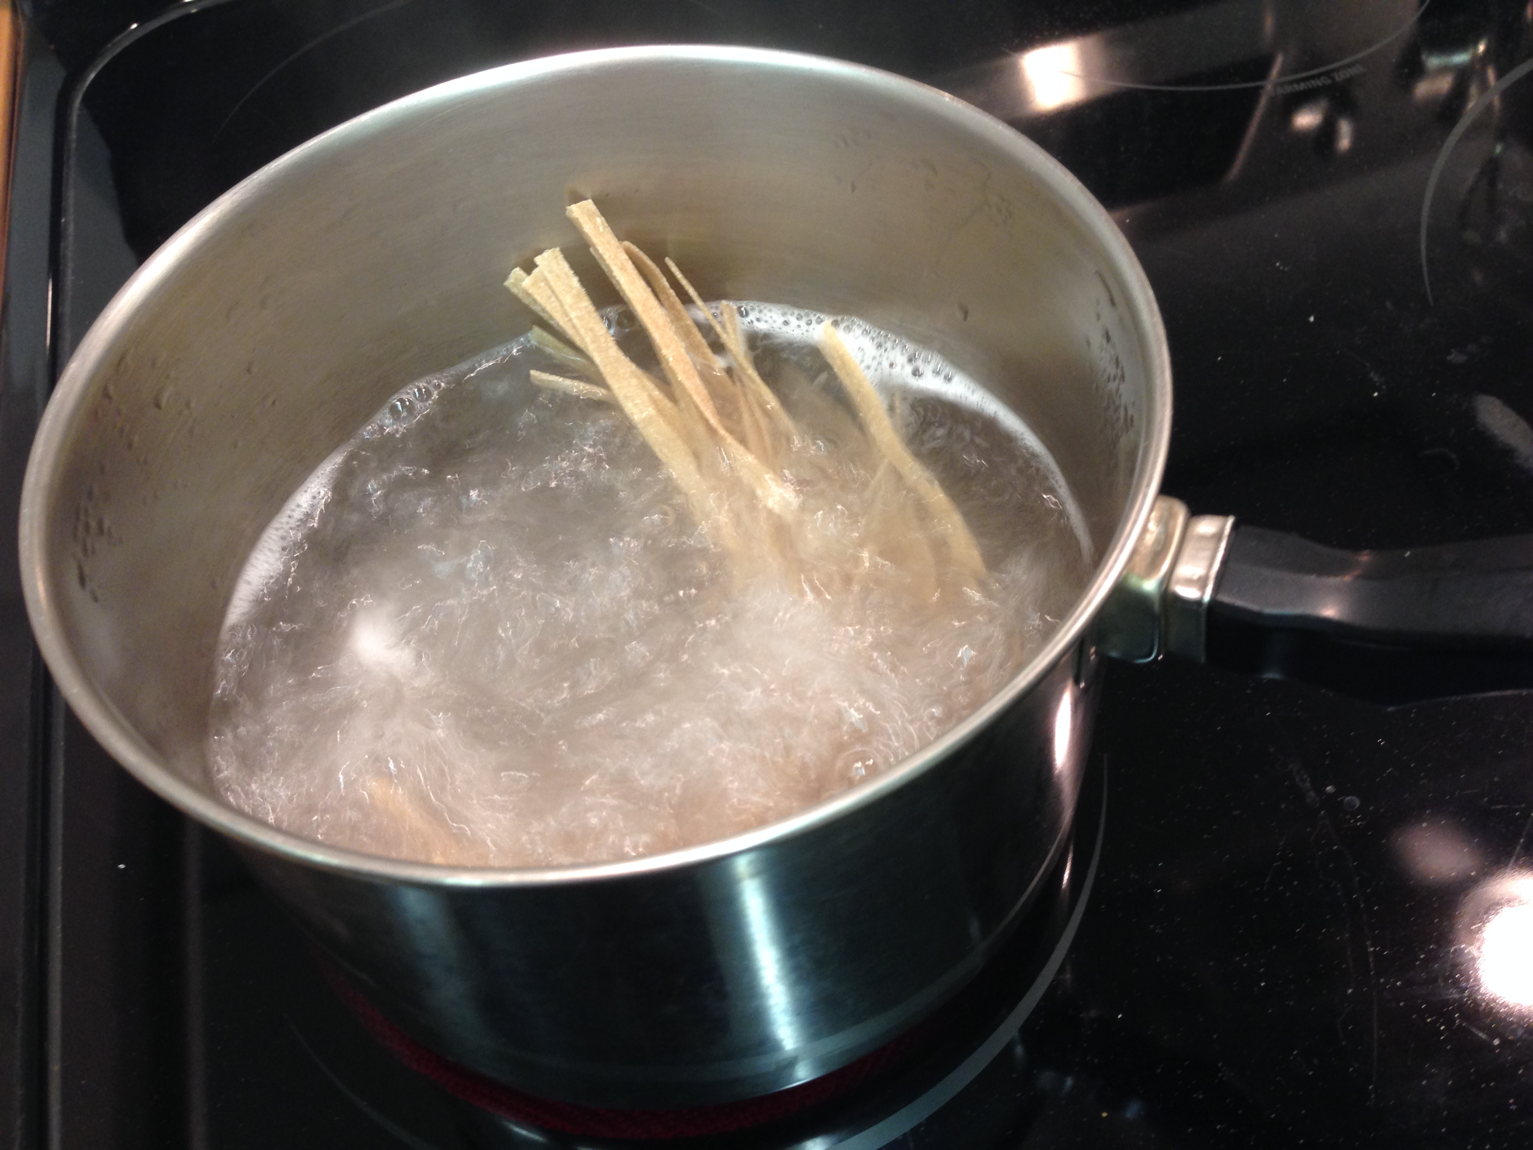

and prevent them from sticking to the bottom of the saucepan.
[] Cook time is 5-10 minutes, according to taste. The pasta is very chewy if cooked for a shorter time, and softer if cooked for the longer time.
[] Remove the pasta to a serving dish using a pasta lifter. Or, drain off the cooking water through a colander before transferring it to a serving dish.

Traditional uses for ribbon pasta
Most pasta in Italy forms the warming base of the plate, onto which is poured a prepared dish of tomatoes or other vegetables with fish, meat, or mushrooms and their natural sauce. For this kind of meal the pasta is plentiful and nicely chewy, or al dente as the Italians would say. A topping of finely grated Parmesan cheese makes the dish even tastier.

In a simple and comforting way ribbon pasta can be served with a light coating of olive oil and a sprinkling of grated well-aged hard cheese such as Parmesan, and freshly chopped herbs.

